|  |  |  |  |  |
| --- | --- | --- | --- | --- |
| |  |  | | --- | --- | | League  Info Server | Image result for football league cup | | Image result for football kick | Image result for football batches | |
| Documentation  Covers Architecture, API Specification using Swagger, Cross Browser & Device UI Testing, UI Unit Testing, UI Automated Testing, Security Testing, Service Unit & Integration Testing, API Performance Testing, Jenkins Pipeline setup, Tech stack used, Deployment structure, Code structure and Static Code Analysis |

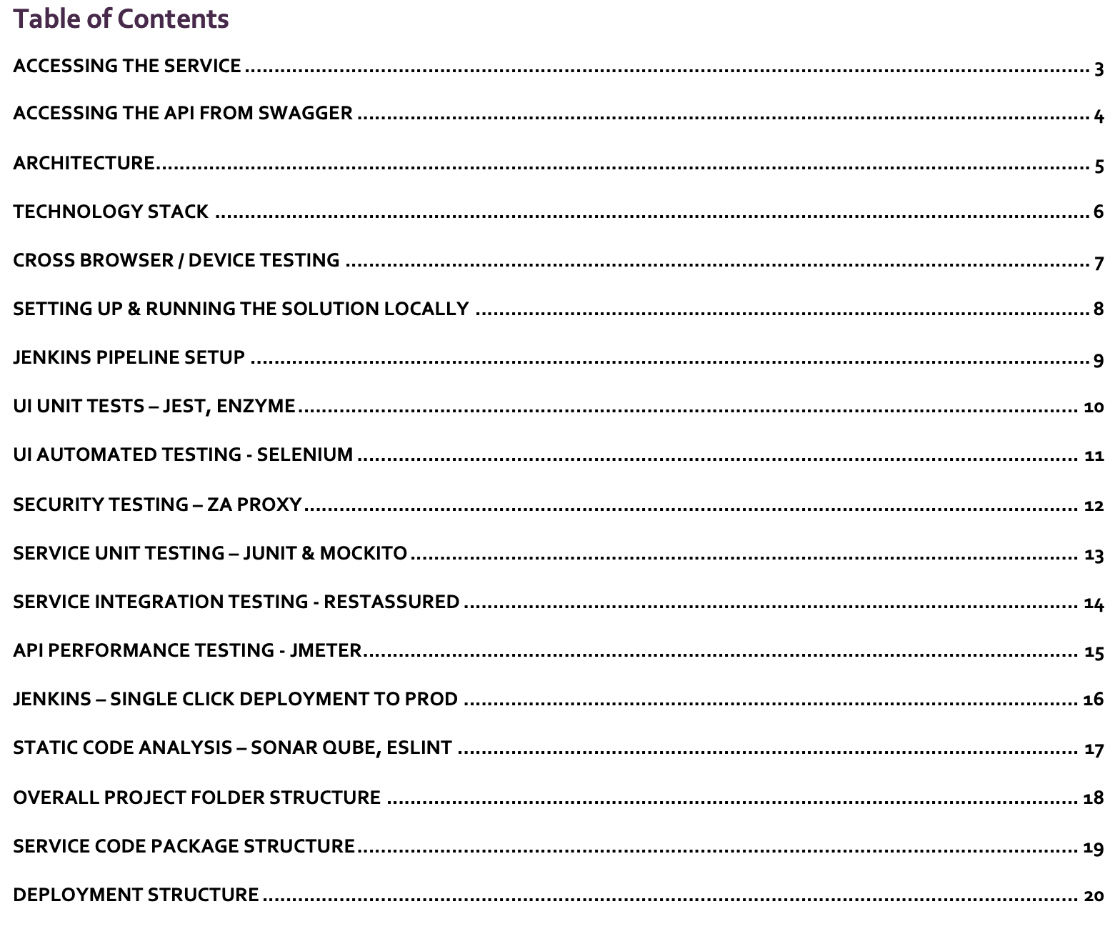

# Cross Browser / Device Testing

Tested the solution in the following browsers & Devices (some of them are listed below): Chrome, Safari, Firefox, Edge, IPhone, IPad, Android

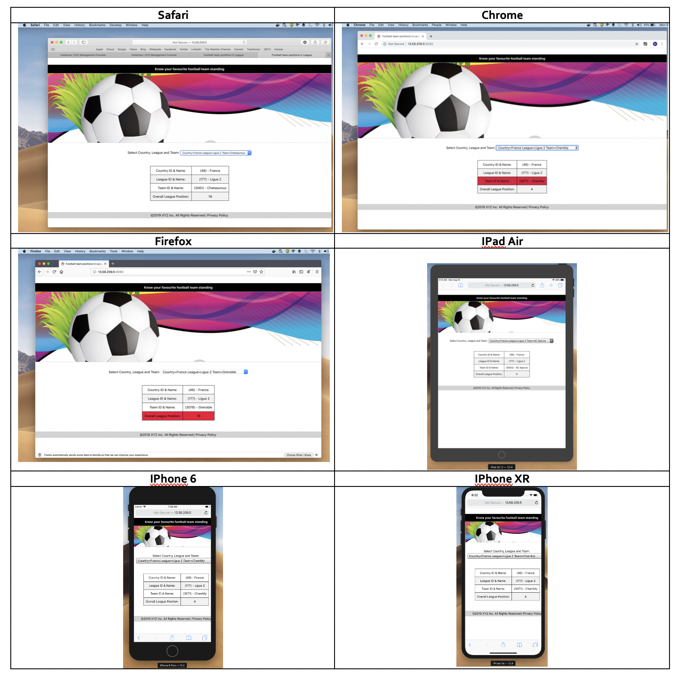

# Accessing the API from Swagger

You can also access the core API via swagger

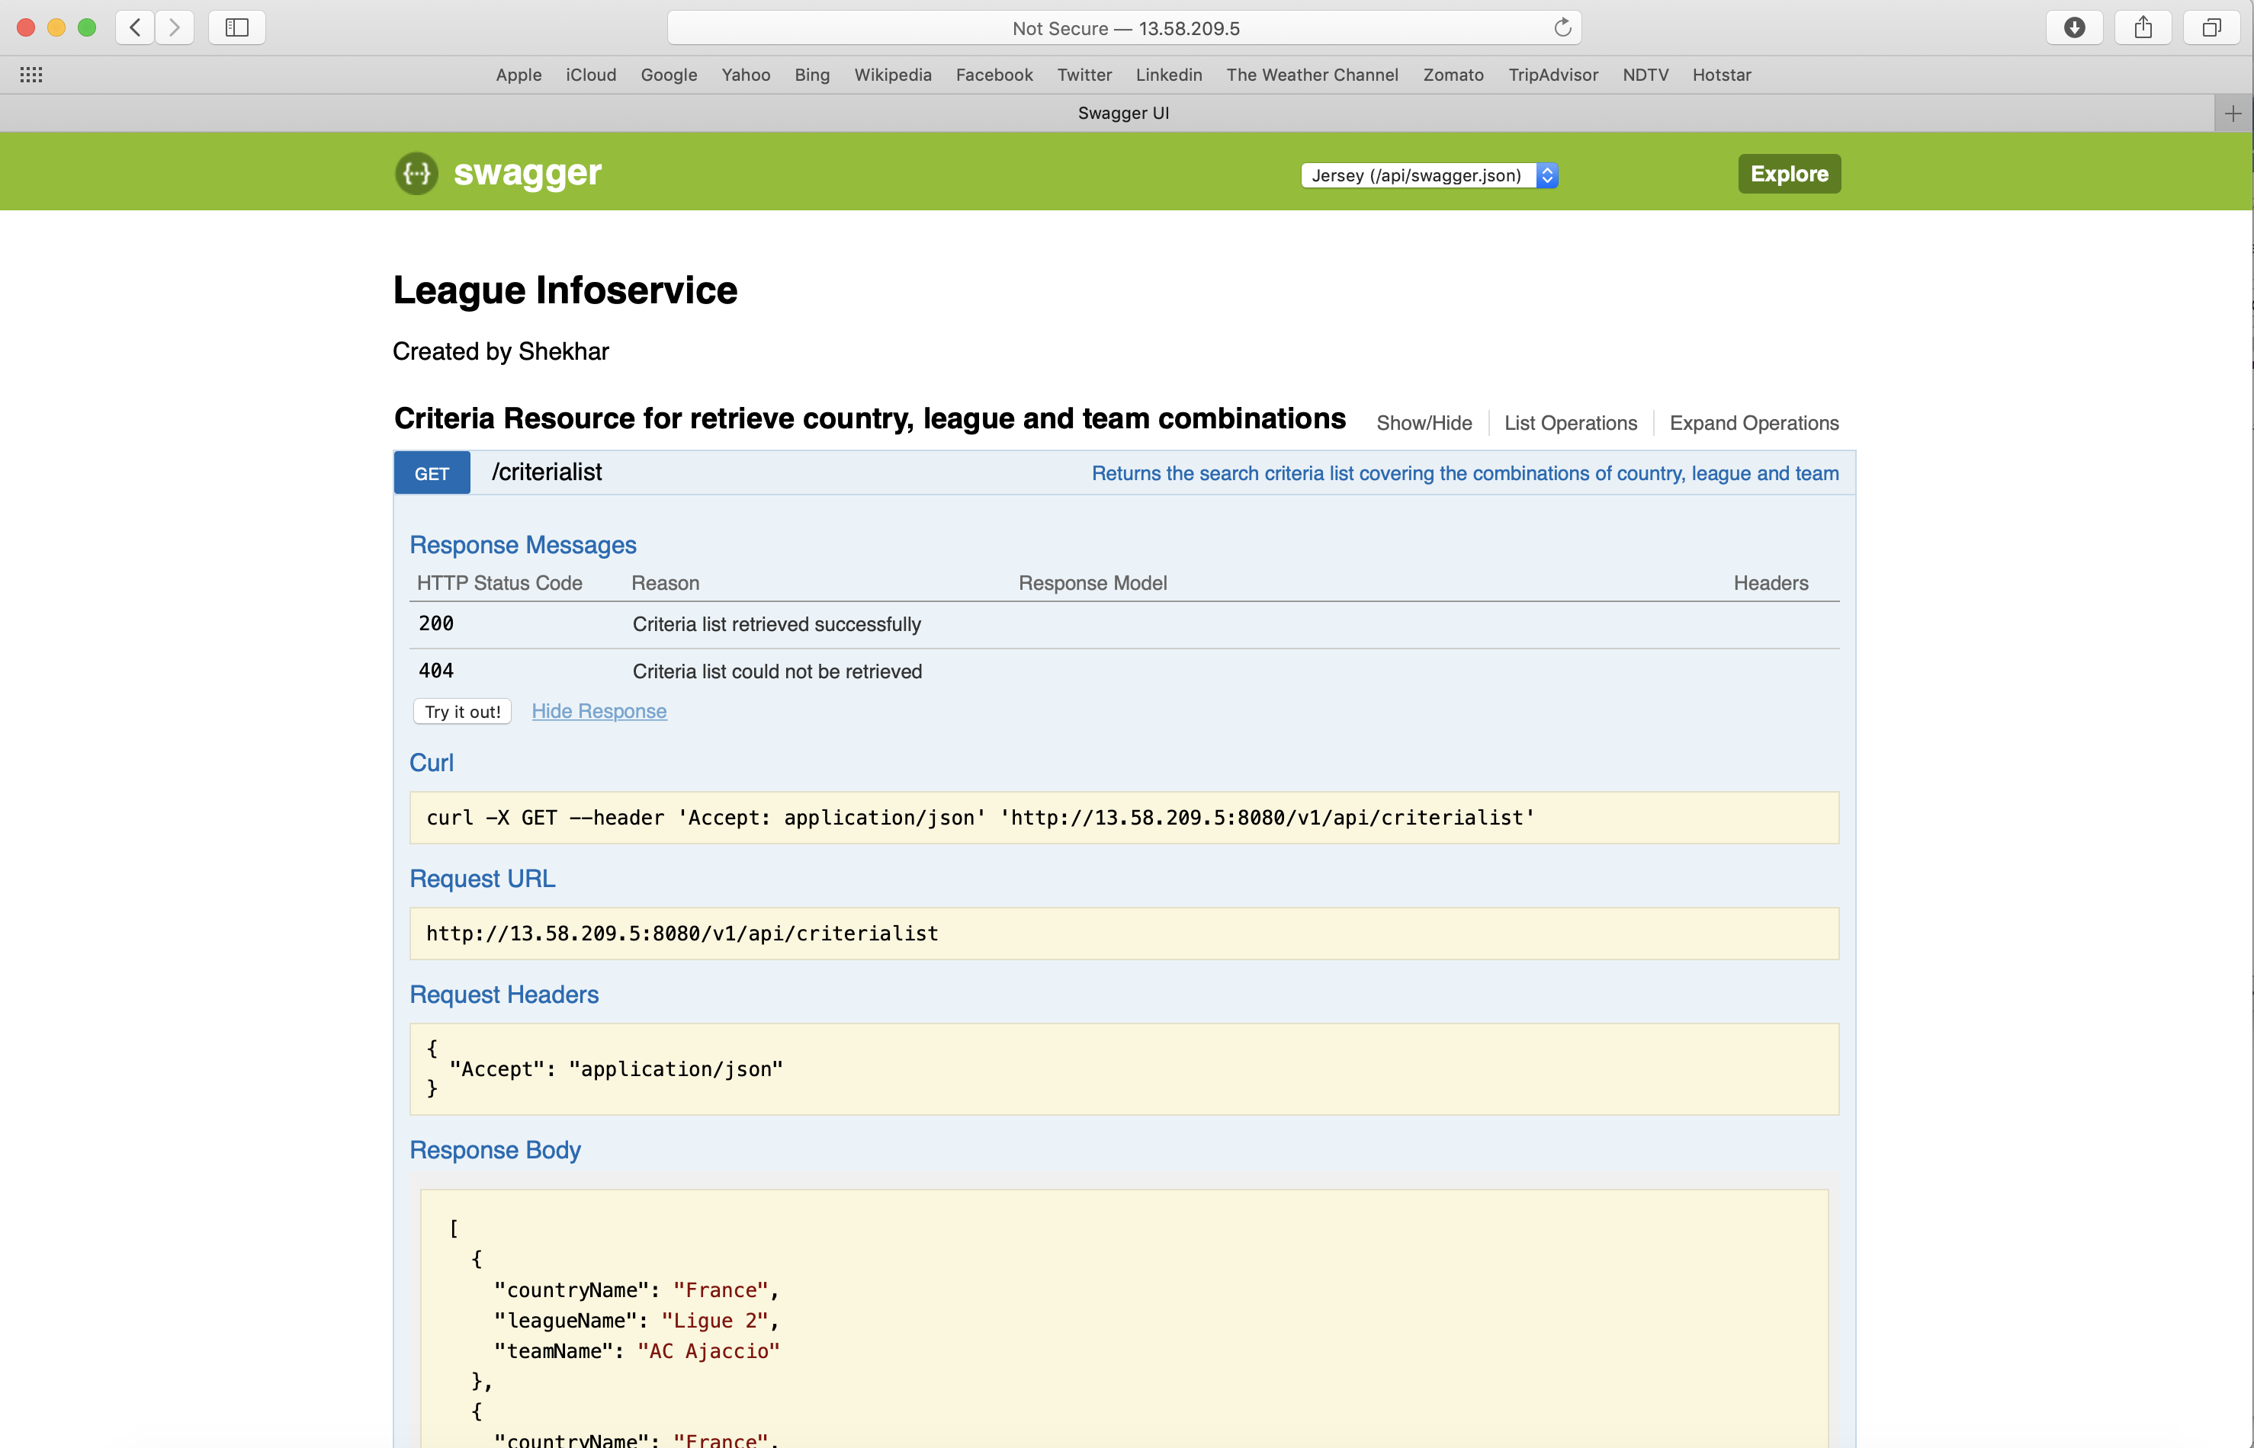

# Technology Stack

